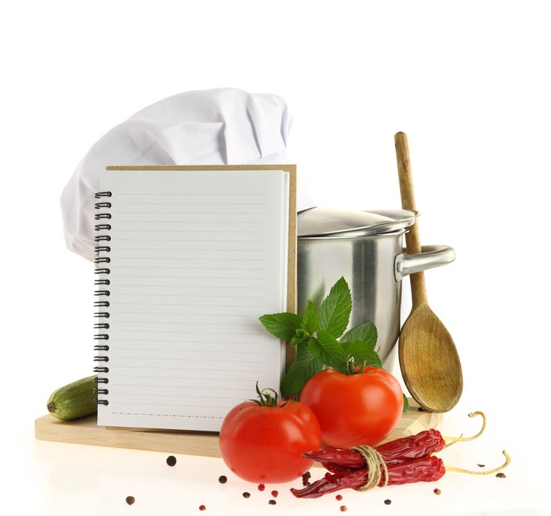
Rezeptname: ______________________________

Zutaten:
________________________________________________________________________________________________________________________________________________________________________________________________________________________
_________________________________________________________________________________________________________________________________________
___________________________________________________________________________________
___________________________________________________________________________________
___________________________________________________________________________________
___________________________________________________________________________________
___________________________________________________________________________________
___________________________________________________________________________________

Beschreibung
______________________________________________________________________________________________________________________________________________________________________
___________________________________________________________________________________
___________________________________________________________________________________
___________________________________________________________________________________
___________________________________________________________________________________
___________________________________________________________________________________
___________________________________________________________________________________
___________________________________________________________________________________
______________________________________________________________________________________________________________________________________________________________________
___________________________________________________________________________________
___________________________________________________________________________________
___________________________________________________________________________________
Kochzeit: _________________________________

Backzeit: __________ Temperatur:_________

